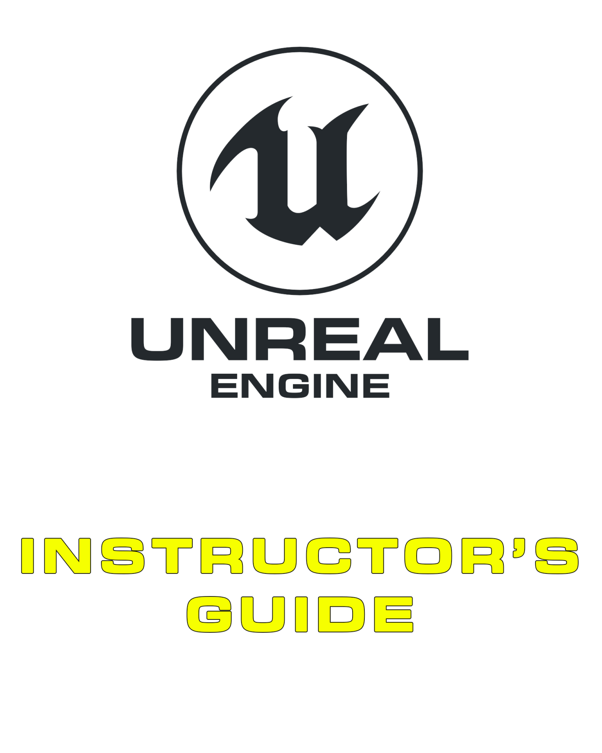

12 Game Marketing

Contents

Overview 3

12.1. Core Concepts 4

Aim 4

Developing Content 4

Platforms 4

Demographics 5

Contacting the Press 6

Press Packs 6

Conduct 7

12.2. Common Mistakes 7

12.3. Supplementary Resources 8

Multiple-Choice Quiz 9

Marketing 101 9

Social Marketing 10

# Overview

**PURPOSE**

The purpose of this tutorial is to outline marketing and assess students’ understanding of how independent developers can (and typically do) market content within the industry.

**SCOPE**

This section will provide an introductory overview of the following:

* Marketing 101
* Social marketing
* Conduct

**PREREQUISITES**

There are no prerequisites for this section.

## 12.1. Core Concepts

### Aim

Successful projects depend on a wide audience, and reaching a wide audience depends on marketing. The first step in marketing is analyzing your project as a product and identifying the best path forward. All marketing requires marketers to work out exactly what they’re trying to accomplish and how they’d like to be recognized. Are you trying to establish yourself as a leader? As something novel and unique? Are you trying to promote a newsletter, demo, or game release? Will you be recognized as approachable or as something more exclusive?

Establishing the general message, the public identity of the team, and the purpose of the messaging is essential for working out a cohesive media strategy.

* What are your objectives?
* What are you offering?
* How are you developing your message? (What are you going to say?)
* Who are your target audience? Do you have competitors?

From here you can start tailoring your message to your audience, developing content, and choosing the appropriate platforms.

### Developing Content

Because social media content can potentially go viral, it’s important to develop content that focuses on quality over quantity. This emphasis ensures that the content developed will be displaying the project in the best possible light.

Following are some useful tips for creating content:

* Only display content that is relevant to what you intend to display. For instance, if a screenshot doesn’t need the editor to be visible, you don’t need to show it.
* When showing videos of an environment, Sequencer can be used to produce smoother and more professional videos than a typical playthrough with a mouse and keyboard.
* Ensure that content has been developed to the correct aspect ratio and resolutions for the platform it will be posted to.
* When recording video content, be sure to use proper video-recording software and not an external mobile device.
* Schedule your content for time zones that match your audience.

### Platforms

#### Websites

Websites are a central hub for your online presence. All other channels that you use should link back to them, so websites need to be well maintained and presented. It’s important to keep a clean design with easily accessible links to your press kit, trailers, and all social media channels.

#### Facebook

Facebook has the largest user base of any social media platform. Facebook posts reach a wide audience; however, be wary of sending multiple posts per day, since the Facebook algorithm begins to hide repeat posts by pages. One of Facebook’s main strengths is that it allows for more detailed posts. The posts can contain more text than Twitter or Instagram posts, and Facebook gives previews to where your posts are linking to, which can be useful.

* You can now use a video clip as your page banner, instead of just a static image.
* Facebook lets you create custom tabs (pages), so make use of them to create dedicated links for signing up to receive newsletters or for finding you on Kickstarter.

#### Instagram

Instagram has a higher engagement rate than either Facebook or Twitter. Reposting is less common, but likes and comments are greater, making it a good place to gather feedback and engage customers in a dialogue.

* When posting on Instagram, be aware that there’s no easy way of clicking on links in a post and that long pieces of text are truncated, so the image typically has to be the focus of the post.
* Remember that Instagram is about the visuals, so focus on high-fidelity images and remember that text-heavy images are less likely to be shared.
* When uploading a video, make sure the first frames look as good as a picture—there’s a half-second delay before a video starts, so if someone’s scrolling down their feed and you can’t get them to pause, they will never see the video.

#### Twitter

Twitter is about short, sharp posts, and because it’s built around sharing content with others via retweets, it has a very wide reach. Due to the short character counts, Twitter has a dialogue that can be hard to maintain.

When posting on Twitter:

* Don’t start tweets with @PersonsName, as the tweet will only appear on that person’s timeline and not be visible to the rest of your followers.
* If you use an image, you can tag up to 10 people in the image, saving on character count.
* When showing off video, **always directly upload it to Twitter** rather than linking out to YouTube, since direct uploads play automatically when scrolled past.

#### Video Services

Video services offer a unique avenue for advertising and publicizing content. YouTube and Twitch both allow for live streaming, which is saved for later viewing. Remember that there are several factors that affect the SEO of your videos, with watch time being more valuable than likes or follows. Keep your content appropriate for those under 18 and avoid swearing or working on anything explicit.

### Demographics

Gamer demographics at a glance:

* The average gamer is 35 years old
* Gamers are 58% male, 42% female.
* Men purchase nearly twice as many titles as women; however, women are a third more likely to make in-app purchases.
* Two-thirds of parents play games with their children weekly.
* The top five countries by game revenue are China, the United States, Japan, South Korea, and Germany.

### Contacting the Press

The first step to take before contacting the press and promoting your game is to identify which press to contact.

While the obvious first choice may be to single out the most highly visited sites, such as Kotaku, IGN, and Polygon, strong competition in the game industry limits the indie’s chances of getting picked up by one of these sites.

Although the odds that the larger sites are out of reach may be daunting, there are other options:

* Seek out smaller sites, bloggers, and vloggers that may respond best to free keys for reviewing/previewing.
* Identify which of the larger sites have sections devoted to games that fit your profile.
* Locate specialist sites that fit your project.
* Research who you’re pitching to, and try to understand what kind of content they’re after and what angle they’ve taken on similar projects.
* Consider personally emailing as many of these sites as possible to avoid your email coming across as spam with generic messages.
* When you reach out, make sure that your email has an actionable response.

### Press Packs

Spreading information about your project goes much more smoothly with a press pack that can be easily linked to in your emails and website.

Content typically covered includes the following:

* Game name
* Studio name
* Studio region
* Publisher name, if applicable
* Website + social links
* Contact details
* Trailer (a link to both a YouTube version and a downloadable version)
* Key art
* Screenshots (high resolution and no logo, making it easier for cropping and formatting for articles)
* Logo
* Description of the game/press release

Because your project may be described in a range of contexts, it’s important to provide alternative versions of your project description. Say what it is in

* Less than 116 characters (this allows a link in a tweet)
* Two sentences
* A paragraph
* A page

### Conduct

When contacting the media, it’s important to keep the following etiquette in mind:

* Be professional.
* Use correct English and grammar.
* Remember to check over your work before you send it through.
* Avoid overselling your game. Keep your descriptions as concise and objective as possible.
* Try to avoid being overly emotional or intense.
* Journalists are very busy people, and they’re often traveling between exhibitions and conferences. If you don’t receive a response straightaway, it’s reasonable to write a follow-up after a week or more, but don’t pursue the matter any further. Sometimes it can take a month to get a response, and sometimes there’s no response at all. Continuous follow-ups will burn goodwill.
* Be truthful.

## 12.2. Common Mistakes

Sometimes it is the simple things that often get overlooked. The following list includes some of the more common examples:

* Incorrect formatting of press pack content
* Poor file-naming standards. (Images with the filename “untitled02.png” are telling.)
* Marketing to an undefined target audience (too broad)
* Waiting until the game is ready to ship before marketing
* Only contacting well-known review sites (for instance, IGN, Polygon)
* Favoring quantity over quality when releasing content via social media

## 12.3. Supplementary Resources

*Marketing for Indies* blog posts by Jess Hider can be accessed at

<https://www.unrealengine.com/en-US/enterprise/blog/marketing-for-indies?lang=en-US>.

# Multiple-Choice Quiz

|  |  |  |  |
| --- | --- | --- | --- |
| Name: |  | Date: |  |

## Marketing 101

1. When should you start thinking about the marketing for your game?
   1. When the game is ready for release
   2. When the game is in beta
   3. During the design phase
   4. Shortly after development has commenced
   5. Never, good games always naturally attract attention from the public and journalists
2. Men are a more likely than women to make an in-app purchase.
   1. True
   2. False
3. When should a screenshot contain editor imagery?
   1. When it’s explicitly relevant
   2. When it’s for a minor feature
   3. Any time it’s convenient
   4. Never
4. What is a press pack?
   1. A panel of journalists reviewing games at an expo or convention
   2. An easily accessible collection of vetted media resources and information about a project
   3. A modified version of a project for exclusive distribution to the media
   4. None of the above

## Social Marketing

1. Which of the following social media services is the best place to market your game?
   1. Facebook
   2. Twitter
   3. Instagram
   4. YouTube
   5. Twitch
   6. All the above
2. Social networking is a high-risk, low-cost option for marketing your game.
   1. True
   2. False
3. Likes are a reliable indicator of marketing success.
   1. True
   2. False
4. If a journalist hasn’t responded to an email straightaway, when should you follow up?
5. Within 24 hours
6. Within 48 hours
7. After a week
8. Never